Relation b/w == operator and equals()

1. 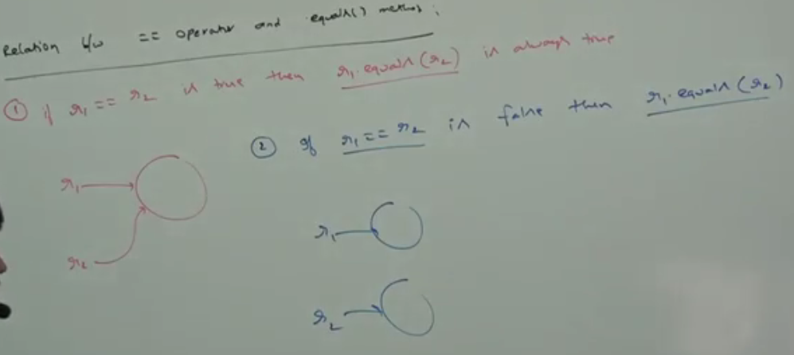  
   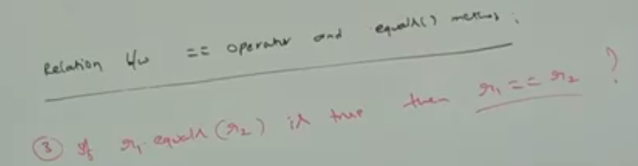 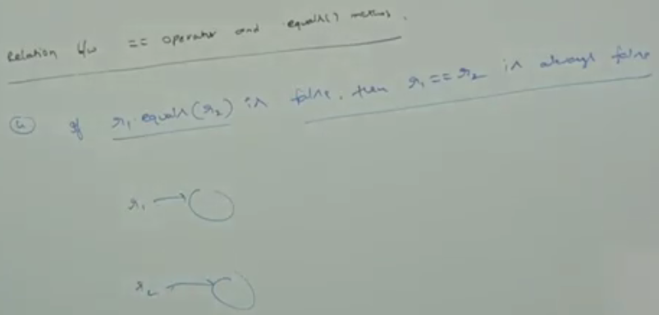

We cann ‘t say anything about r1 == r2🡪 no single conclusion ☺

1. d\

Difference b/w == and equals()

1. To use == operator, compulsory there should be relationship b/w operands (either child-parent or parent-child or same type) otherwise we will get compile time error saying 🡪 Incompatible type
2. If there is no relationship b/w operands, then .equls() doesn’t error any compile time or run time error. Simply it returns false.  
   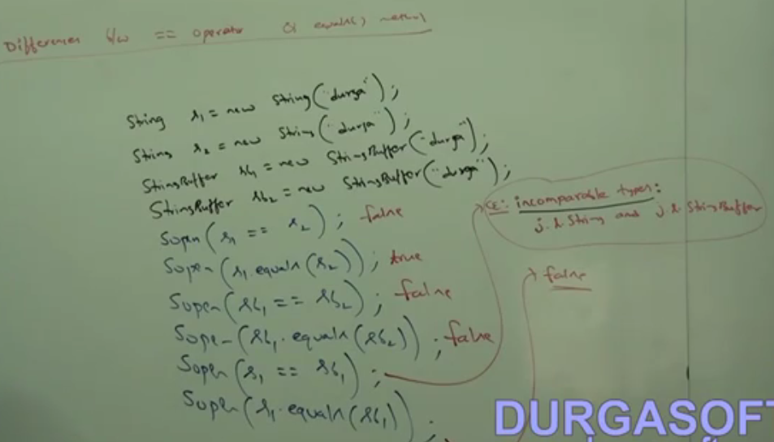

|  |  |
| --- | --- |
|  |  |
| It’s operator which is Applicable for primitive and  object type | Method which is applicable for object not for primitive |
| In case of object reference, this operator is meant for  Reference comparison | By default, equals() in Object is also meant for reference  Comparison |
| We can’t override == operator for content comparison | we can override for content comparison |
| To use == operator, compulsory the operands should be  In relation such as parent-child, child-parent, or same  Type | If there is no relation b/w operands then .equals() will not raise any compile or run time error. |

1. In general, we can use == operator for reference comparison and .equals() for content comparison.
2. NOTE: For any object reference r,   
   r == null 🡪 false  
   r.equals(null) 🡪 false
3. **NOTE**: hashing related data structure follows the following fundamental rule  
   Two equivalent objects should be placed in same bucket but all objects present in the same bucket need not to be equal.
4. Construct b/w.equals() and hashCode()
   1. If two objects are equal by .equals() then they must have same hash code.
5. Object class .equals() and hashCode() follows the above contract. Hence, whenever we are overriding .equals(), compulsory we should override hashCode() to satisfy the above contract.
6. If two objects are not equals(), then there is no restriction on hash code they may be same or different.
7. While generating hash code, keep in mind that those only those variables which have been used in equals() for comparison.